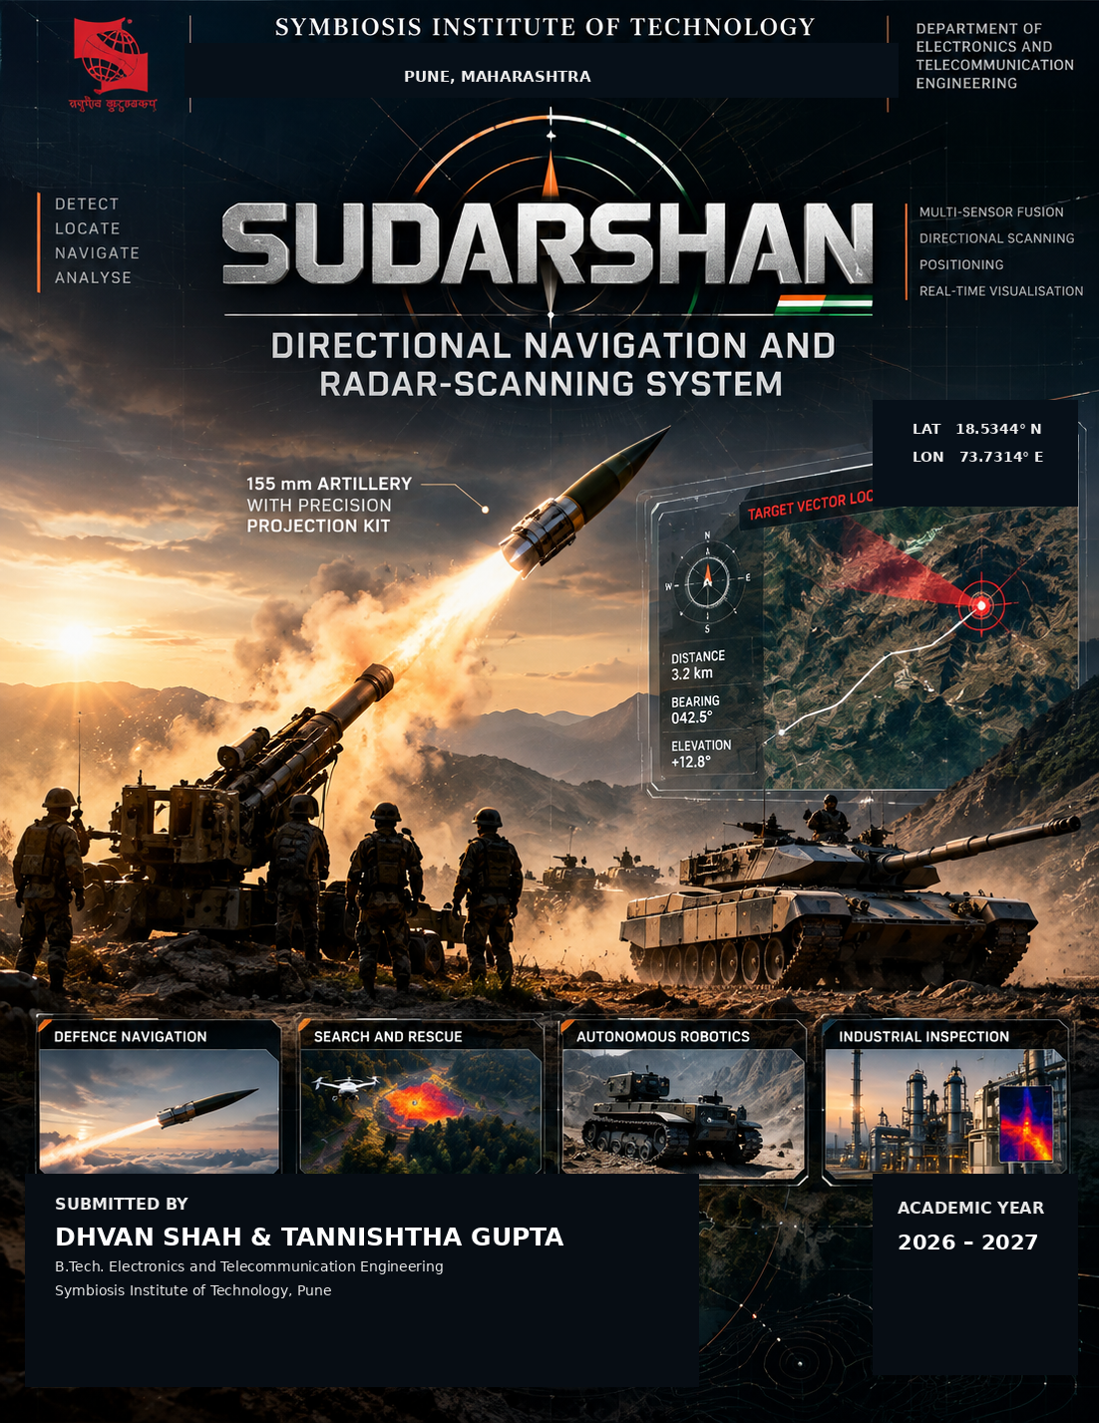

PROJECT REPORT
SUDARSHAN
Directional Navigation and Radar-Scanning System
Submitted by
Dhvan Shah – 2507023042
Tannishtha Gupta – 25070123049
Under the Guidance of
Mrs. Shilpa Hudnurkar
Department of Electronics and Telecommunication Engineering
S.Y. B.Tech. Electronics and Telecommunication Engineering
SYMBIOSIS INSTITUTE OF TECHNOLOGY, PUNE

ACKNOWLEDGEMENT
We would like to express our sincere gratitude to Mrs. Shilpa Hudnurkar, Department of Electronics and Telecommunication Engineering, Symbiosis Institute of Technology, Pune, for her guidance and support throughout the development of this mini project.
We are thankful for the knowledge and practical understanding gained through the Microcontrollers and Applications course, which helped us in developing the hardware interfacing, sensor integration and control concepts required for this project.
We would also like to acknowledge the various technical learning resources and YouTube tutorials that helped us understand and implement concepts related to Arduino interfacing, GPS communication, MPU6050-based orientation sensing, servo control, RF receivers and infrared temperature sensing. These resources were particularly useful during circuit development, troubleshooting and hardware testing.
Finally, we thank our department and institute for providing the laboratory facilities and an environment that allowed us to work on the project and gain practical experience in embedded systems and sensor-based engineering.

ABSTRACT
SUDARSHAN – Directional Navigation and Radar-Scanning System is an integrated multi-sensor platform developed for directional sensing, navigation support and spatial estimation where positional and directional information need to be considered together. The project brings together low-cost sensing modules and a computer-based dashboard so that individual observations can be viewed in one common directional frame.
The prototype uses a NEO-6M GPS module for geographical reference, a 433 MHz receiver for digital RF detection, an MLX90614 for non-contact temperature measurement and an MPU6050 for motion and orientation information. An Arduino Uno R3 handles sensor acquisition and sends the collected data to the SUDARSHAN dashboard through USB serial communication. Angular observations used by the present prototype can be entered or positioned manually; an automated servo mechanism was evaluated during development but is not required for the current sensing demonstration.
The main processing step is directional vector fusion. Sensor observations are associated with their corresponding bearing and represented in a common frame. The RF and thermal responses are then combined to obtain a resultant direction. This allows the dashboard to show whether the available sensor evidence is pointing toward a similar region instead of treating every reading as an unrelated value.
The resulting workflow connects physical sensing, data acquisition, directional analysis and visualization in a single prototype. The design is intended to demonstrate the sensing and fusion concept clearly while keeping the hardware practical to assemble and test.

1. INTRODUCTION
Modern navigation and sensing systems often need information from more than one sensor before a useful spatial decision can be made. In defence and other remote-field applications, compact sensing units can combine geographical reference, orientation and directional observations as part of a larger navigation architecture. SUDARSHAN was developed as a small-scale academic prototype to demonstrate this type of multi-sensor approach.
SUDARSHAN combines geographical positioning, RF detection, infrared temperature sensing and inertial measurements within one acquisition system. The NEO-6M provides the geographical reference, while the 433 MHz receiver and MLX90614 contribute direction-dependent observations. The MPU6050 provides motion and orientation information. These measurements are collected by the Arduino Uno R3 and transferred to the SUDARSHAN dashboard, where they can be viewed and processed in relation to direction.
The main idea behind the system is to put the different observations into the same directional frame. A reading taken at one bearing is treated as a directional contribution rather than only as a numerical value. Contributions from the available sensors are then combined to obtain a resultant direction and an indication of the region associated with the stronger combined response.

1.1 System Objective
The primary objective of SUDARSHAN is to combine position reference, sensor observations and directional analysis in one practical prototype. The system is intended to convert individual measurements into a common spatial representation that can be inspected through the dashboard, while keeping the hardware simple enough for laboratory-level testing.

2. BLOCK DIAGRAM
The SUDARSHAN architecture separates the system into sensing, data acquisition, directional analysis and visualization. GPS establishes the reference position, the RF and thermal modules provide the main directional observations, and the MPU6050 supplies orientation-related information. The Arduino Uno acquires the sensor data and transfers it to the computer for processing and dashboard display. Angular positions can be set manually in the current prototype, while automated positioning remains an optional future addition.
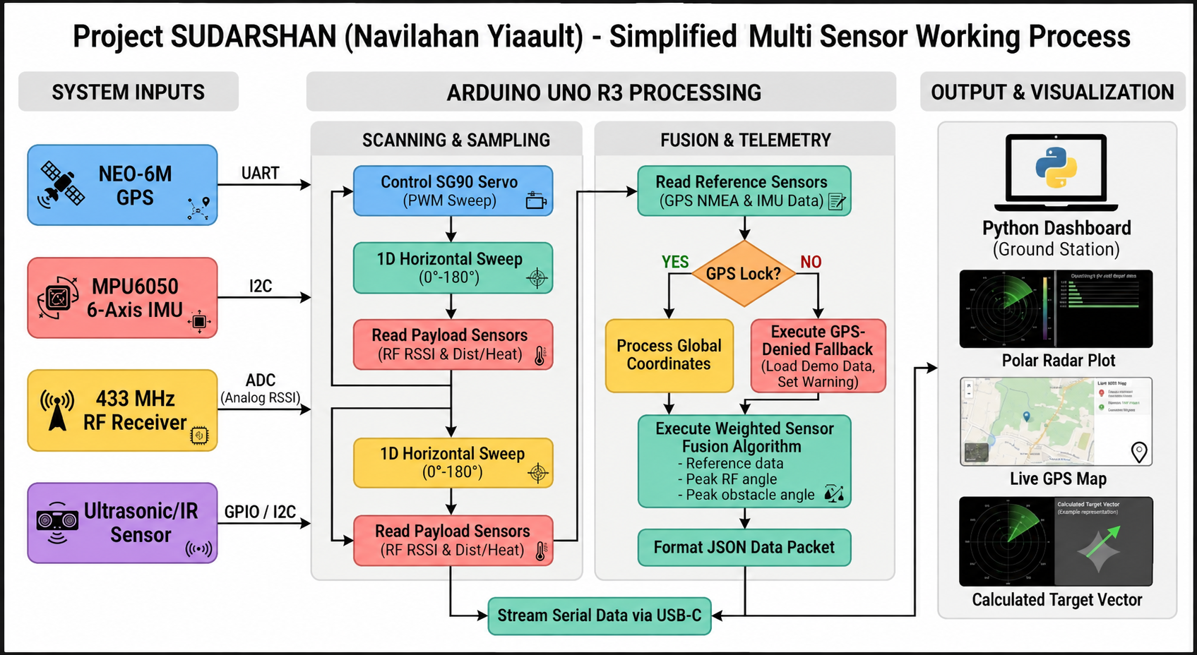
Fig. 1. Functional block diagram of the SUDARSHAN system
The NEO-6M provides the geographical reference, while the RF receiver and MLX90614 supply the main direction-dependent observations. The MPU6050 adds motion and orientation information that can be used when interpreting the sensor arrangement. The Arduino Uno handles acquisition and USB serial communication. During analysis, each observation is associated with a bearing, represented as a directional contribution and combined with the other available observations to obtain the resultant direction shown by the dashboard.

3. SELECTION OF COMPONENTS
Component selection was based on interface compatibility, availability, ease of integration and suitability for a compact laboratory prototype. The final sensing set provides geographical reference, digital RF detection, thermal observation and orientation information. An SG90 servo was also evaluated during development for automated angular positioning, but manual positioning is used for the present prototype.
Component | Primary Function | Selection Basis | Photo
Arduino Uno R3 | Central controller and data acquisition | Used as the main sensor-acquisition controller and USB serial interface. | 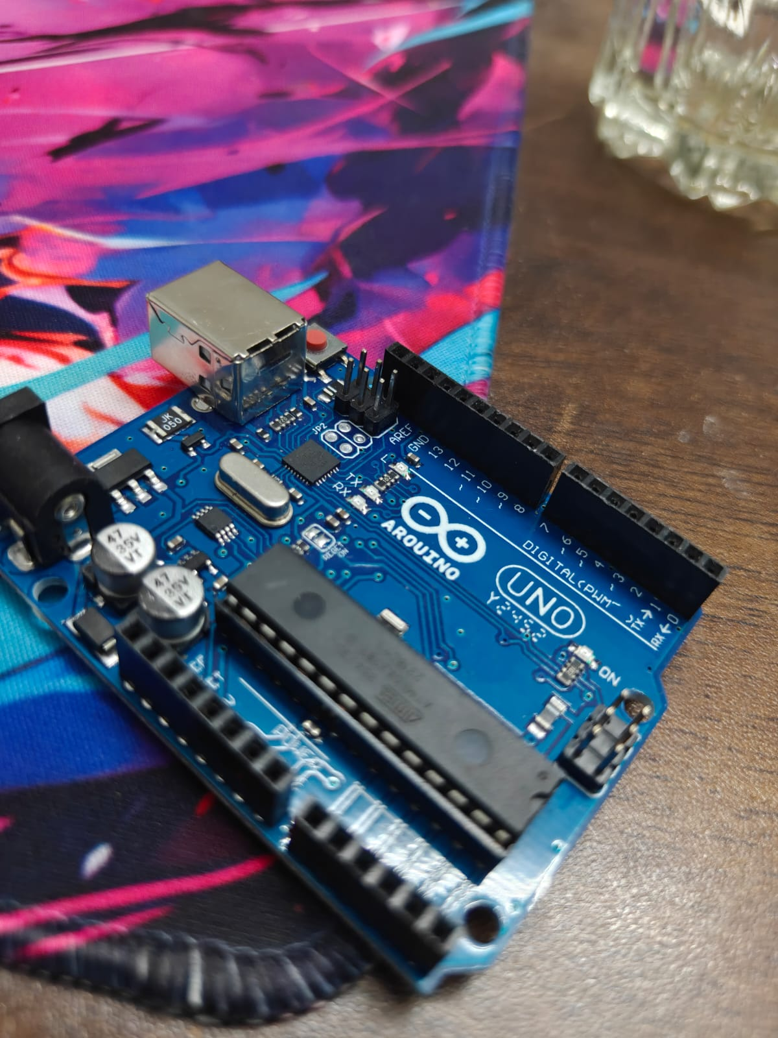
NEO-6M GPS | Geographical position | Collects absolute geographical coordinates through UART. | 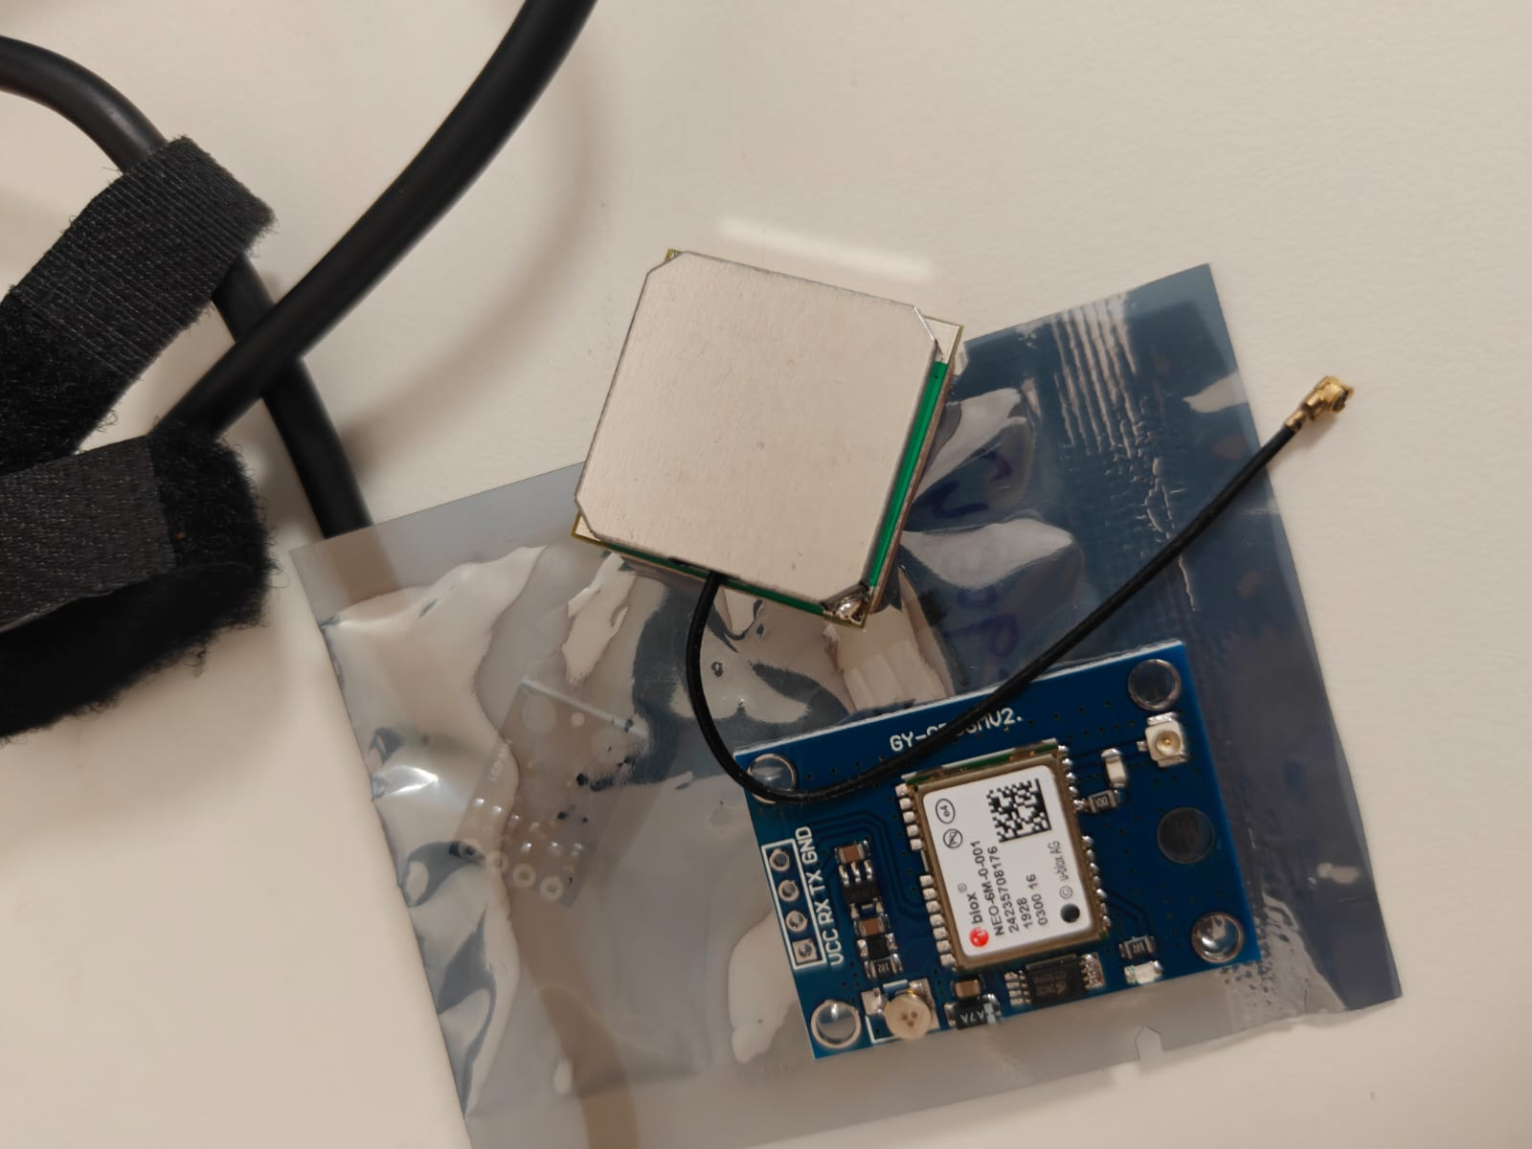
433 MHz RF Receiver | Digital RF detection | Provides digital RF detection through its DATA output. | 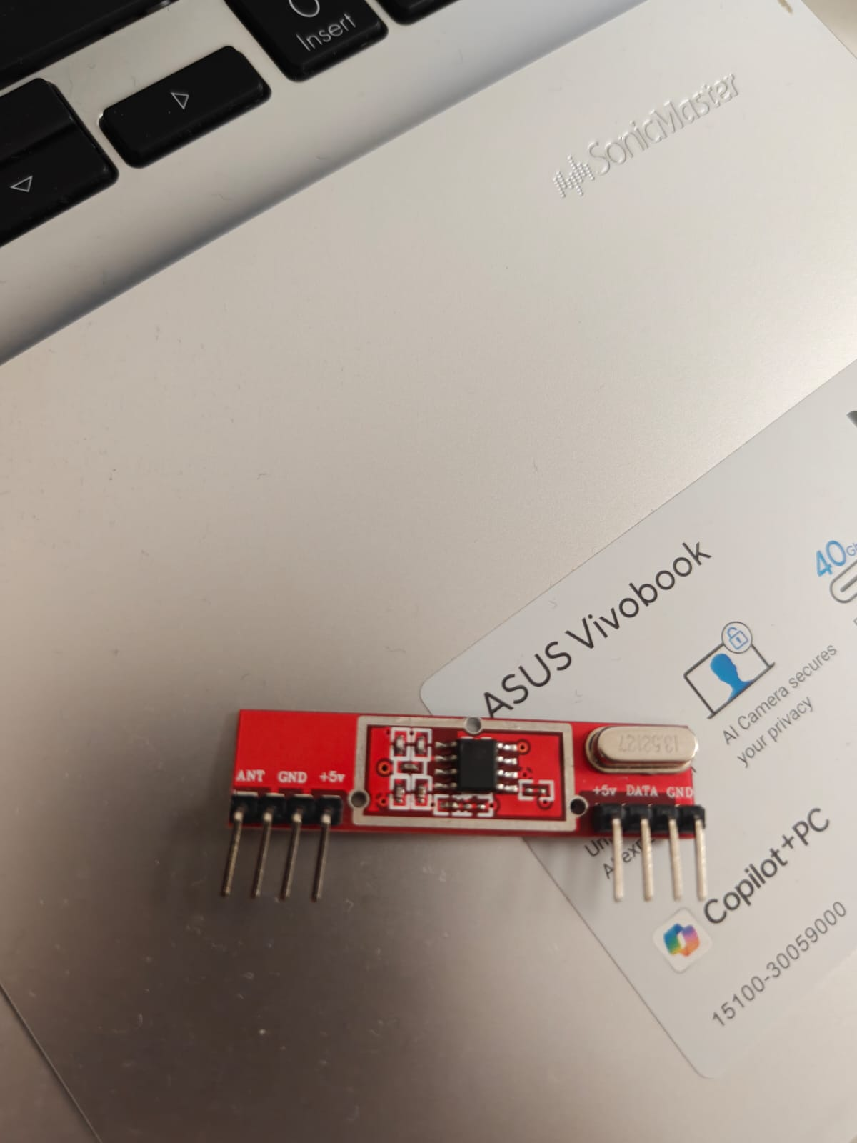
MLX90614 | Infrared temperature sensing | Provides non-contact object and ambient temperature measurements. | 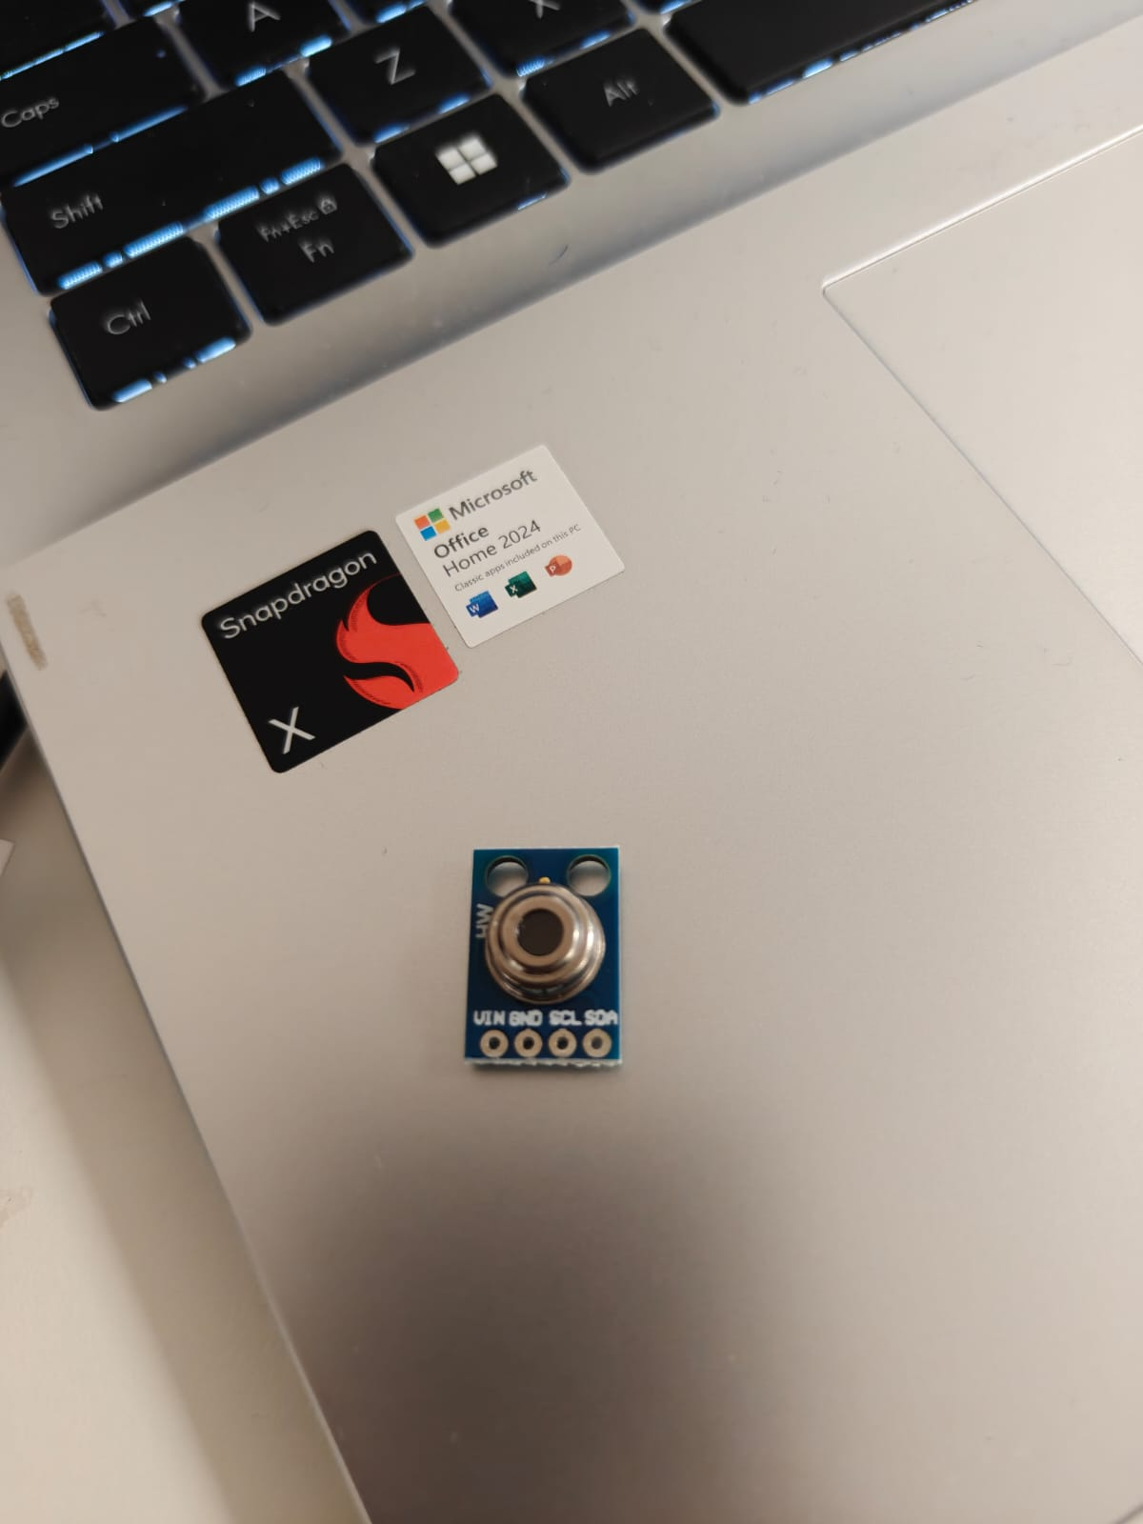
MPU6050 | Motion and orientation sensing | Combines accelerometer and gyroscope measurements through I²C. | 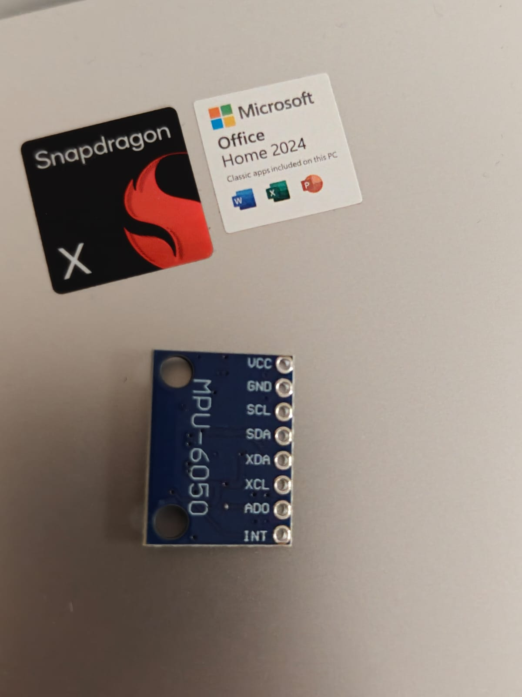
SG90 Servo (optional) | Optional angular positioning | Evaluated for automated scanning; manual angular positioning is used in the current prototype. | 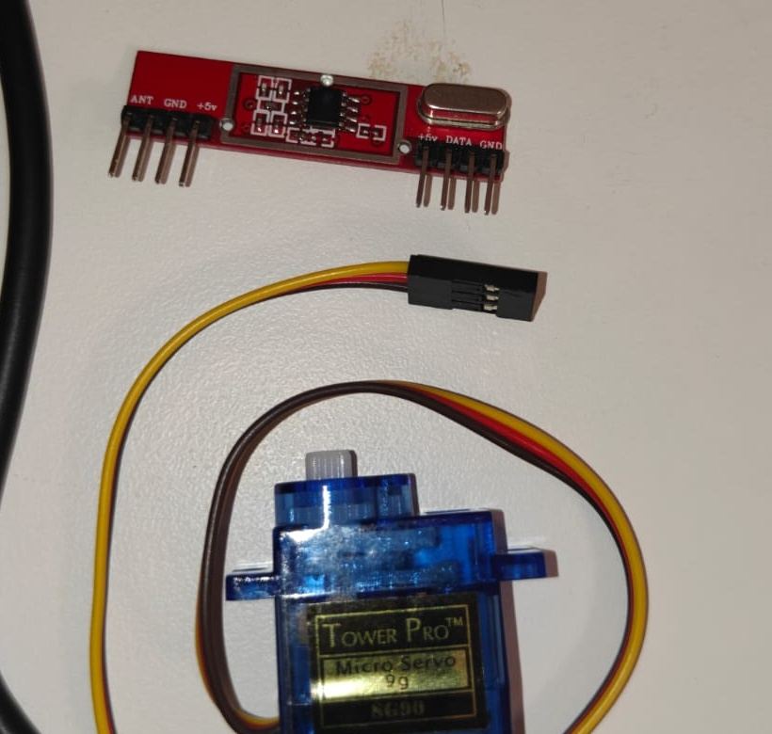
Table 1. Selected components and their functional justification

3.8 Bill of Materials
Sr. | Component | Qty. | Approx. Cost (₹)
1 | Arduino Uno R3 | 1 | 550
2 | NEO-6M GPS Module + Antenna | 1 | 300
3 | 433 MHz RF Receiver | 1 | 150
4 | MPU6050 6-Axis IMU | 1 | 160
5 | SG90 Servo (optional) | 1 | 100
6 | MLX90614 IR Temperature Sensor | 1 | 480
7 | Breadboard + Jumper Wires | 1 set | 200
Table 2. Bill of materials

4. WORKING AND SYSTEM IMPLEMENTATION
4.1 Hardware Implementation
The present prototype uses the Arduino Uno R3 as the main data-acquisition controller. The NEO-6M, 433 MHz digital RF receiver, MPU6050 and MLX90614 are connected to the controller and their readings are transferred to the computer through USB serial communication. Angular position is set manually during the current demonstration so that readings can be taken at known bearings without making the sensing system dependent on an actuator.
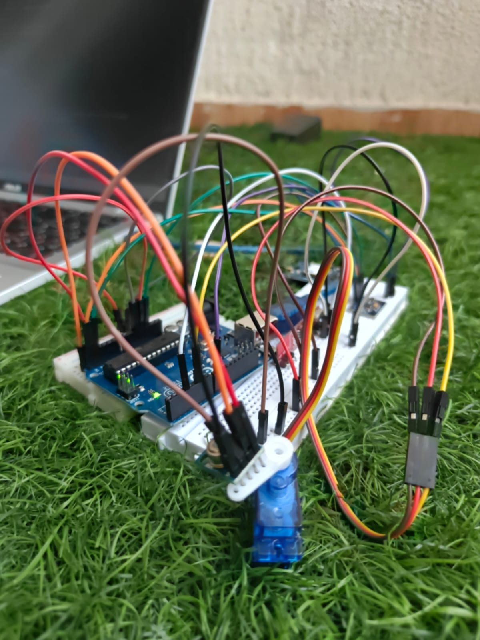
Fig. 2. SUDARSHAN hardware prototype during sensor integration and actuator evaluation

4.2 Vector Summation and Directional Fusion
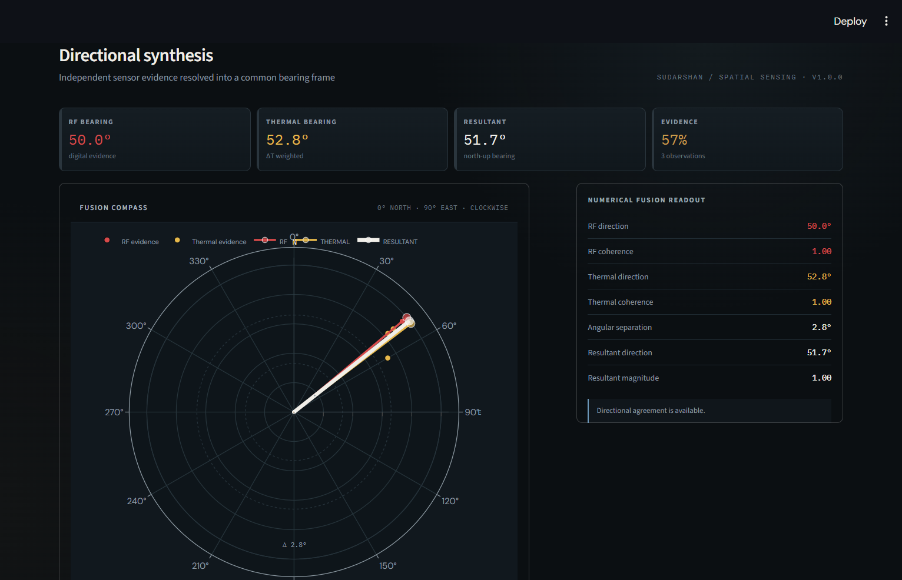
Fig. 3. Vector summation and directional fusion output in the SUDARSHAN dashboard
For each observation, the sensor reading is linked to the bearing at which it was recorded. The dashboard places the RF and thermal observations in a common directional frame and combines their contributions to obtain a resultant vector. In the displayed example, the RF direction is 50.0° and the thermal direction is 52.8°, giving an angular separation of 2.8°. Their combined result is 51.7°, showing that the two available observations are closely aligned. The resultant is therefore used as a compact representation of the combined directional response rather than as a direct measurement of distance or exact target position.
5. PROBLEMS FACED AND DESIGN MODIFICATIONS
During integration and testing, the team identified a few practical limitations that affected how the final prototype was arranged. These were not changes to the basic sensing idea; they were design decisions made after seeing how the modules behaved when assembled together. The main points were GPS antenna placement, automated actuator requirements and the complexity of the initial controller arrangement.
5.1 GPS Antenna Placement
The NEO-6M antenna works more reliably when it is kept in an open position with a clear view of the sky. When the antenna was surrounded by wiring or placed too close to other parts of the prototype, obtaining a stable fix became less convenient during testing. This is a characteristic of the GPS receiving arrangement rather than a software fault in SUDARSHAN.
For testing, the ceramic antenna was kept externally exposed and away from unnecessary obstructions. When a live GPS fix is not immediately available, the dashboard can also use a manually entered reference coordinate for controlled testing. The manual value is treated only as a reference for evaluation; it does not replace the GPS measurement.
5.2 Servo Power Requirement and Manual Operation
An SG90 servo was initially considered for automatic angular scanning. During integration, it became clear that reliable movement required a separate, stable 5 V supply with sufficient current, in addition to a mechanically secure mounting arrangement. The actuator therefore introduced power and mechanical dependencies that were not necessary for validating the main sensing and vector-fusion functions of the prototype.
For the present version, the servo is treated as an optional actuator rather than a required part of the sensing chain. Angular positions are selected manually during testing, allowing the RF and thermal observations to be collected at known bearings without depending on the actuator. Automated scanning can be added later when a suitable power and mechanical arrangement is available.
5.3 Controller Integration: ESP32 to Arduino Uno
An ESP32-based arrangement was considered during the initial development, but handling the GPS serial interface, I²C sensors, RF input and dashboard communication in the same embedded workflow made the prototype harder to integrate and debug than necessary. The issue was not that the ESP32 is generally incapable of these tasks; the chosen implementation simply added unnecessary integration overhead. The architecture was therefore simplified by using the Arduino Uno R3 for sensor acquisition and USB serial communication, while the computer handles the higher-level data processing and dashboard display. This separation made individual sensor readings easier to inspect and kept vector-fusion development independent of the microcontroller.
These changes kept the prototype focused on the part of the project that had to be demonstrated: acquiring real sensor data, relating it to direction and presenting the combined response clearly. The actuator and automatic scanning can remain future extensions rather than becoming dependencies of the present system.

6. APPLICATIONS OF THE PROJECT
The value of SUDARSHAN lies not only in the prototype demonstrated in the laboratory, but also in the way the same sensing architecture can be adapted to different field requirements. The applications below are considered from the perspective of the hardware and processing approach developed in this project. They represent potential system-level uses; the present prototype is a low-cost academic demonstrator and would require substantial engineering, environmental qualification and platform-specific integration before deployment in operational systems.
Table 2. Potential application areas of the SUDARSHAN architecture
Application area | Role of the sensing architecture | Practical relevance
Defence precision-navigation support | Combines geographical reference, orientation and directional sensor observations within a compact processing architecture. | Provides a conceptual sensing layer for future precision-navigation or guidance-kit development.
Search and rescue / disaster response | Uses position, thermal observation, RF detection and orientation information to build a common spatial picture. | Can support rapid inspection of difficult or hazardous areas by ground teams, robots or unmanned platforms.
Drone and unmanned-system sensing | Provides a lightweight basis for collecting and correlating location, thermal, RF and orientation data. | Can be adapted for aerial inspection, surveillance support, infrastructure monitoring and selected counter-UAS sensing tasks.
6.1 Precision-Navigation Support for Defence Applications
Conventional 155 mm artillery projectiles are generally unguided and do not carry the type of onboard navigation electronics found in specialised precision-guided ammunition. Modern precision ammunition can instead incorporate a dedicated guidance and navigation package to add positional and control capability to the projectile. This distinction is important because the guidance package is an additional technology layer rather than a standard feature of every 155 mm round. Public information from the Ministry of Defence also shows the development of Indian 155 mm smart ammunition incorporating guidance, navigation and control functions, demonstrating the broader relevance of compact navigation electronics to precision artillery technology.
Within this context, SUDARSHAN can be considered as a conceptual sensing subsystem for a future precision projectile or guidance kit. The hardware developed in this project combines geographical reference from the NEO-6M, orientation information from the MPU6050 and direction-dependent observations from the RF and thermal sensors. These measurements are brought into a common processing framework and represented through the vector-fusion method demonstrated by the prototype. The purpose of this approach is to provide a compact spatial picture from multiple observations rather than relying on one sensor alone.
For the Indian defence ecosystem, the significance of the concept is the possibility of developing indigenous, modular sensing electronics that can be studied as part of larger precision-navigation architectures. The present SUDARSHAN prototype is not a flight-qualified guidance system and is not intended to provide operational targeting or fire-control functions. Its contribution is at the prototype level: demonstrating how position, orientation and directional observations can be acquired, combined and visualised using readily available electronic modules.
6.2 Search, Rescue and Disaster-Response Operations
Search-and-rescue environments often contain areas that are difficult or unsafe for personnel to inspect directly. A sensing unit that combines geographical position with thermal and radio-frequency observations can provide additional information to an operator while the unit is moved through or around the affected area. Thermal sensing is already used by first responders for applications such as search and rescue and hot-spot detection, while unmanned aircraft are being studied specifically for locating people and improving the speed of emergency response.
A field-adapted SUDARSHAN unit could therefore be mounted on a small ground robot, inspection platform or other portable carrier. The GPS module would establish the position of the sensing unit, the MLX90614 could provide non-contact temperature observations, the RF receiver could indicate the presence of detectable RF activity, and the MPU6050 could provide orientation information. The dashboard could then present these observations together so that an operator can identify areas requiring closer inspection.
This application is particularly relevant to collapsed structures, remote terrain, post-disaster inspection and other situations where access is restricted. The strength of the concept is not that any one sensor can identify a person or hazard by itself, but that several observations can be viewed in relation to position and direction. A future version could also combine the same architecture with a thermal camera, higher-sensitivity RF sensing and wireless communication to increase practical field capability.
6.3 Drone, Unmanned-System and Counter-UAS Sensing
The compact nature of the selected modules also makes the sensing architecture suitable for adaptation to unmanned platforms. A drone or mobile robotic system can carry sensors into areas that are difficult to access and can transmit observations to an operator for analysis. The use of thermal sensing and data-driven location methods on unmanned aircraft has already been explored for first-responder applications, while defence organisations also use multi-sensor systems for detecting and tracking unmanned aerial threats.
In a future SUDARSHAN-based unmanned platform, the GPS and MPU6050 could provide the platform reference and orientation, while thermal and RF observations could be associated with the platform heading and presented on a common spatial display. This could support applications such as infrastructure inspection, remote-area surveillance, disaster assessment and environmental monitoring. In a security-oriented configuration, RF and other passive sensing methods could also contribute to a broader counter-UAS detection architecture, although dedicated radar, RF analysis and identification hardware would be required for a practical operational system.
The present project therefore demonstrates a useful building block rather than a complete drone or counter-UAS product. Its main transferable idea is the organisation of heterogeneous sensor observations into one spatial representation. With further development in wireless communication, power management, sensor range, vibration resistance and onboard processing, the architecture could be adapted to a range of unmanned-system applications.

7. CONCLUSION
The development of SUDARSHAN provided practical experience in integrating multiple sensors into a single embedded system and relating their measurements to a common directional representation. The Arduino Uno R3, NEO-6M GPS, 433 MHz digital RF receiver, MLX90614 and MPU6050 were interfaced and tested as part of the prototype, with the acquired data transferred to the dashboard for analysis. The project also demonstrated vector-based fusion of directional observations and showed how information from different sensors can be combined to obtain a more useful spatial result. During development, issues related to GPS antenna placement, servo power requirements and controller integration were identified and addressed through changes to the system arrangement.
One of the main outcomes of the project was the practical understanding gained from these issues. The testing process showed that reliable system development depends not only on circuit connections, but also on studying the operating conditions, interfaces, power requirements and limitations of each component before integration. This helped the team identify where more detailed hardware research should have been carried out at the beginning and how early component-level decisions can affect the complete system. SUDARSHAN therefore serves both as a working academic prototype and as a foundation for further development, with future improvements possible in sensing capability, automated scanning, communication, power management and spatial processing.

